Agenda- Maintain three decision tables to get the score on a scale of 1-5 for attendance, test marks, and project marks. [ex, attendance percentage >=90, return 5, 80-90, return 4, 70-80, return 3 etc]. Call this decision table from a data transform to add all these scores. Set the result as qualified when the final score is above 10, otherwise set the result as not qualified

In order to aceive this we need 3 decision tables shown as below

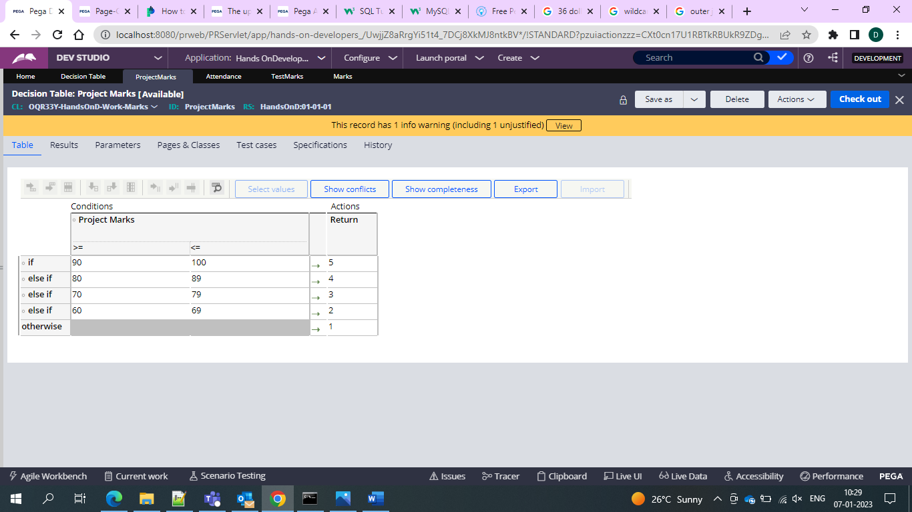

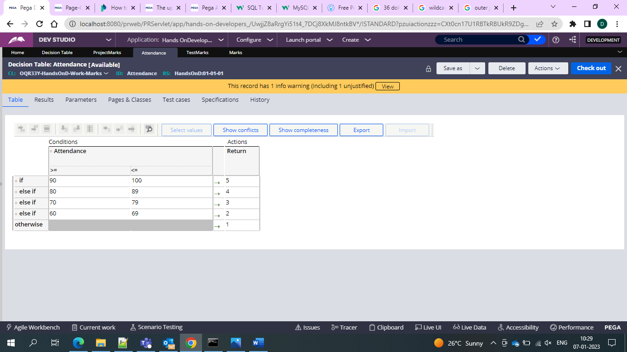

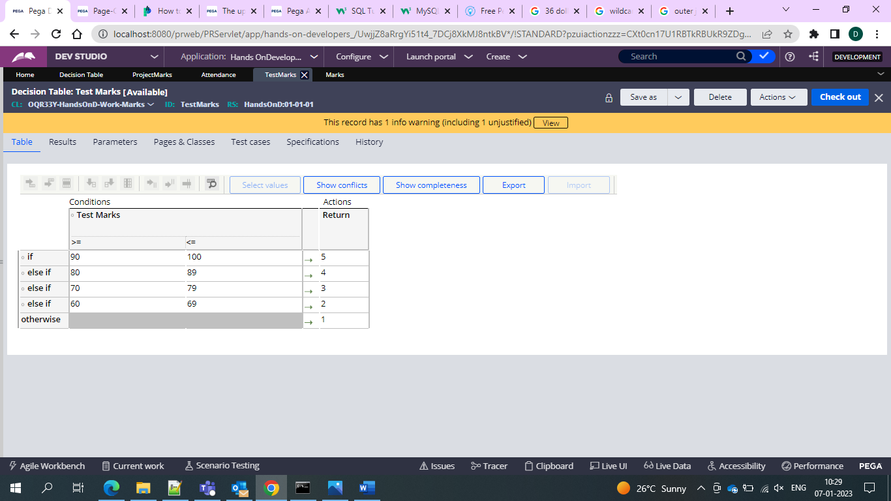

**And then** we need to create case type for first capturing the result

So firstwe need to add the fields as project marks attendance and test result as the fields and in the post processing we need to get the result. Now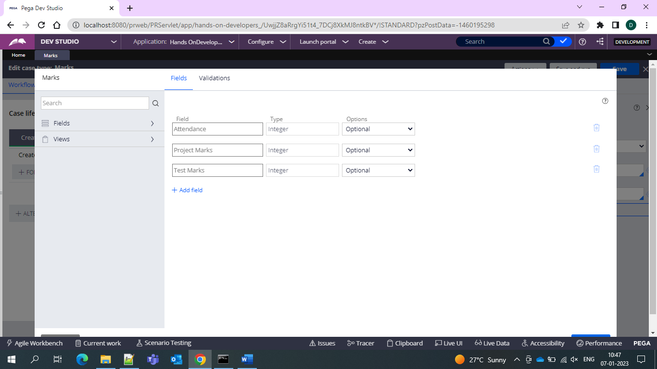

And then add on emore stage to display the result

And for displaying the result we are using DT on the post processing of the flow action

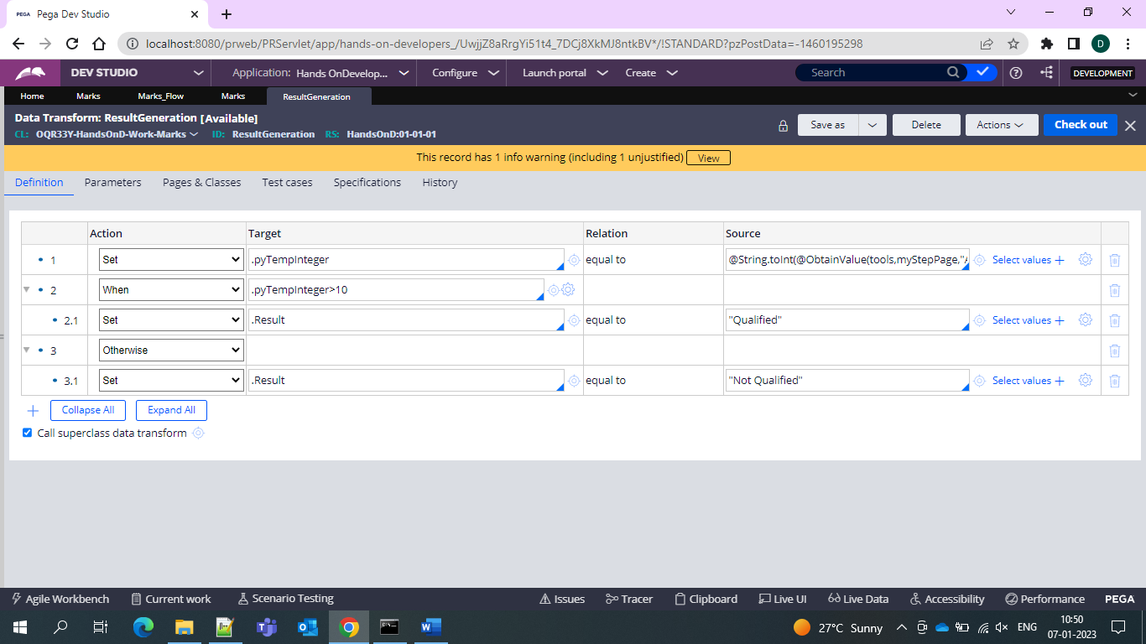

In the DT for the first step we are calling Decision table and setting it to a integer value

And now in the second step we areusing when this integer value>10 then what it should set

It should set as result as qualified otherwise not qualified

And hence the result is calculated by decision table and based on the result it sets as qualified or not qualified

